

***Jack’s Beetle***

Jack ran in the park.

He ran after a beetle.

The little beetle hid in the grass.

Jack looked and looked.

He could not find it.

1. Where did Jack run?

——————————————————————-

2. What did Jack do?

——————————————————————-

3. Was the beetle big or little?

——————————————————————

4. Where did the beetle hide?

——————————————————————

5. Did Jack find the beetle?

——————————————————————



***The Lost Kitten***

A little, grey kitten was lost.

It was lost in the grass.

The kitten was sad.

A little girl saw the kitten.

She took the kitten home.

1. What was lost?

——————————————————————-

2. Where was it lost?

——————————————————————-

3. What colour was the kitten?

——————————————————————

4. Who saw the kitten?

——————————————————————

5. How did the kitten feel?

——————————————————————

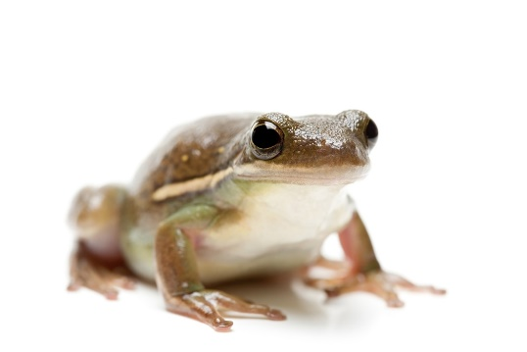

***Ben’s Frog***

Ben had a frog in a box.

The frog was little and green.

Ben found it in the park.

The frog was by a rock.

He gave it to his friend.

1. What did Ben have?

——————————————————————-

2. Where did Ben keep his frog?

——————————————————————-

3. What colour was the frog?

——————————————————————

4. Where did Ben find the frog?

——————————————————————

5. What did Ben do with the frog?

——————————————————————

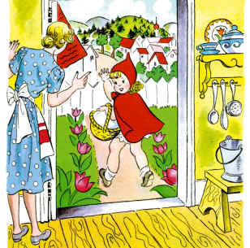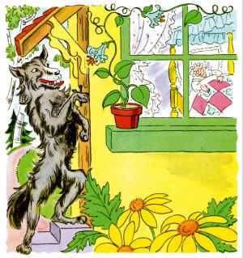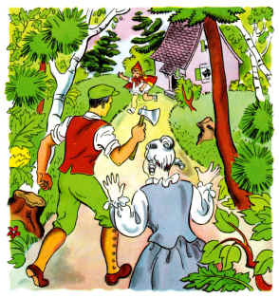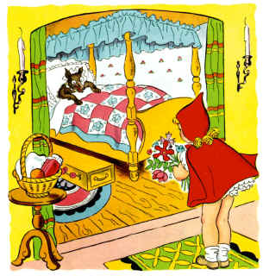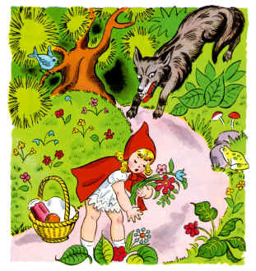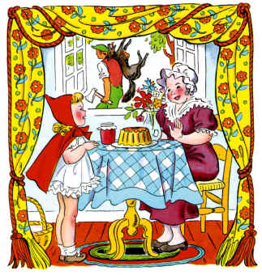

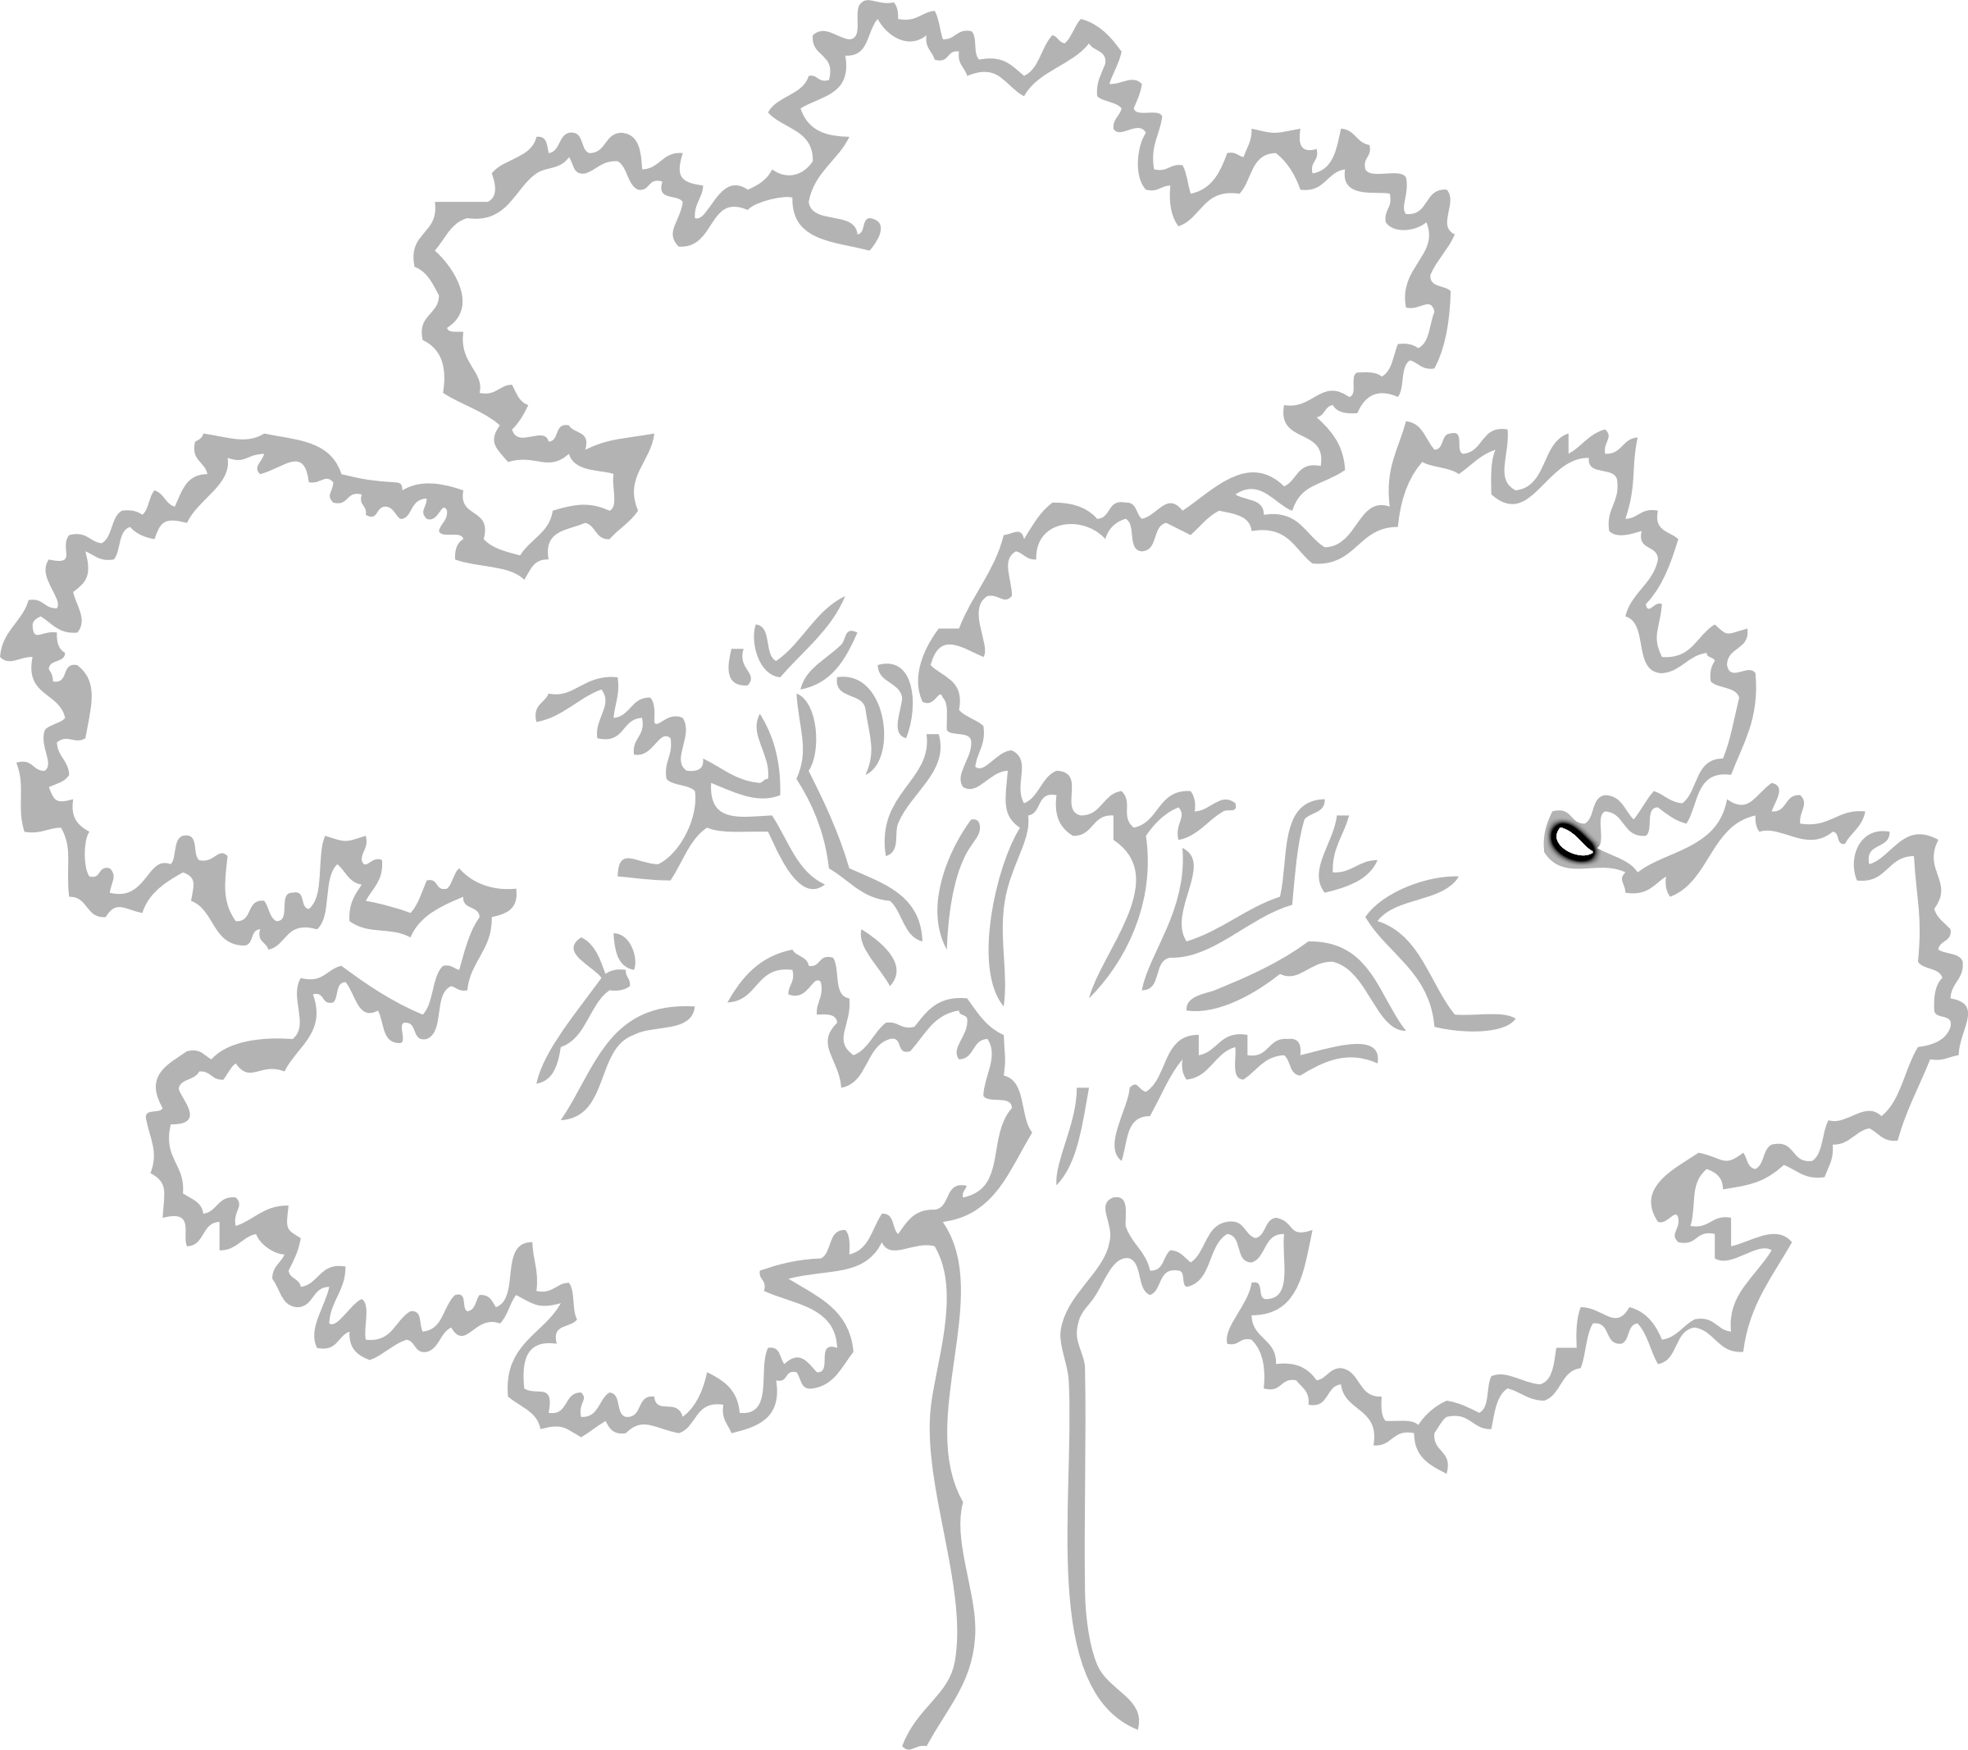

**O ______________________**

**a _____________________**

**k _____________________**

**T _____________________**

**r _____________________**

**e _____________________**

**e _____________________**

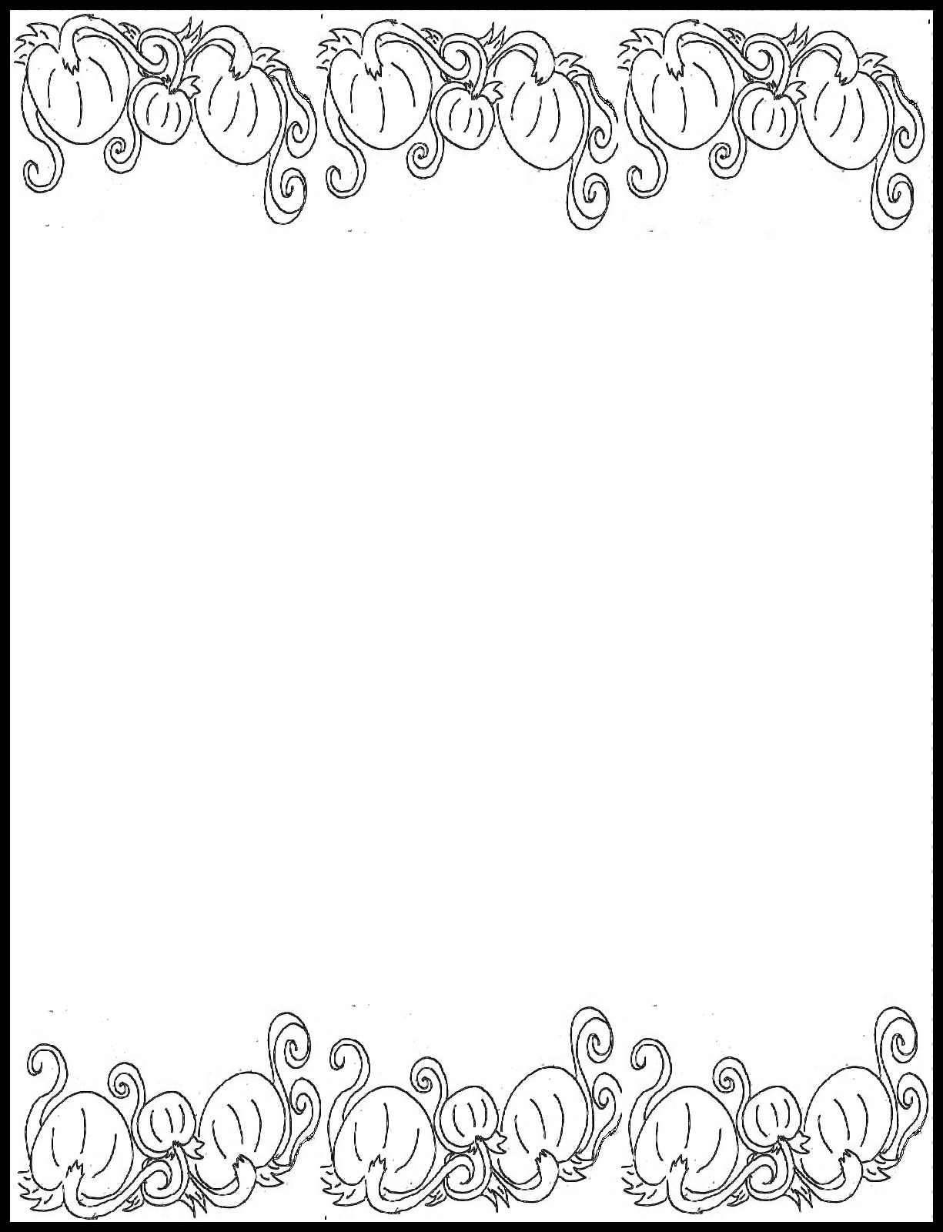

S _______________

P _______________

R _______________

I _______________

N _______________

G _______________

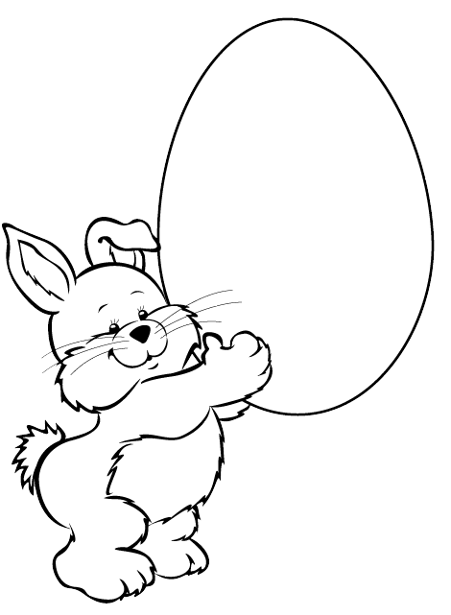

**E ________________**

**A ________________**

**S ________________**

**T ________________**

**E ________________**

**R ________________**