

**Enrichment Activities**

 Try ‘Squid the Fish’ Yoga’: <https://www.youtube.com/watch?v=LhYtcadR9nw>

 Make a yummy dessert. **Can you write a list of the ingredients you used? Can you write a recipe?**

Lego Challenge:Build your house out of Lego, **does your house have stairs or a garage? How many blocks did you use?**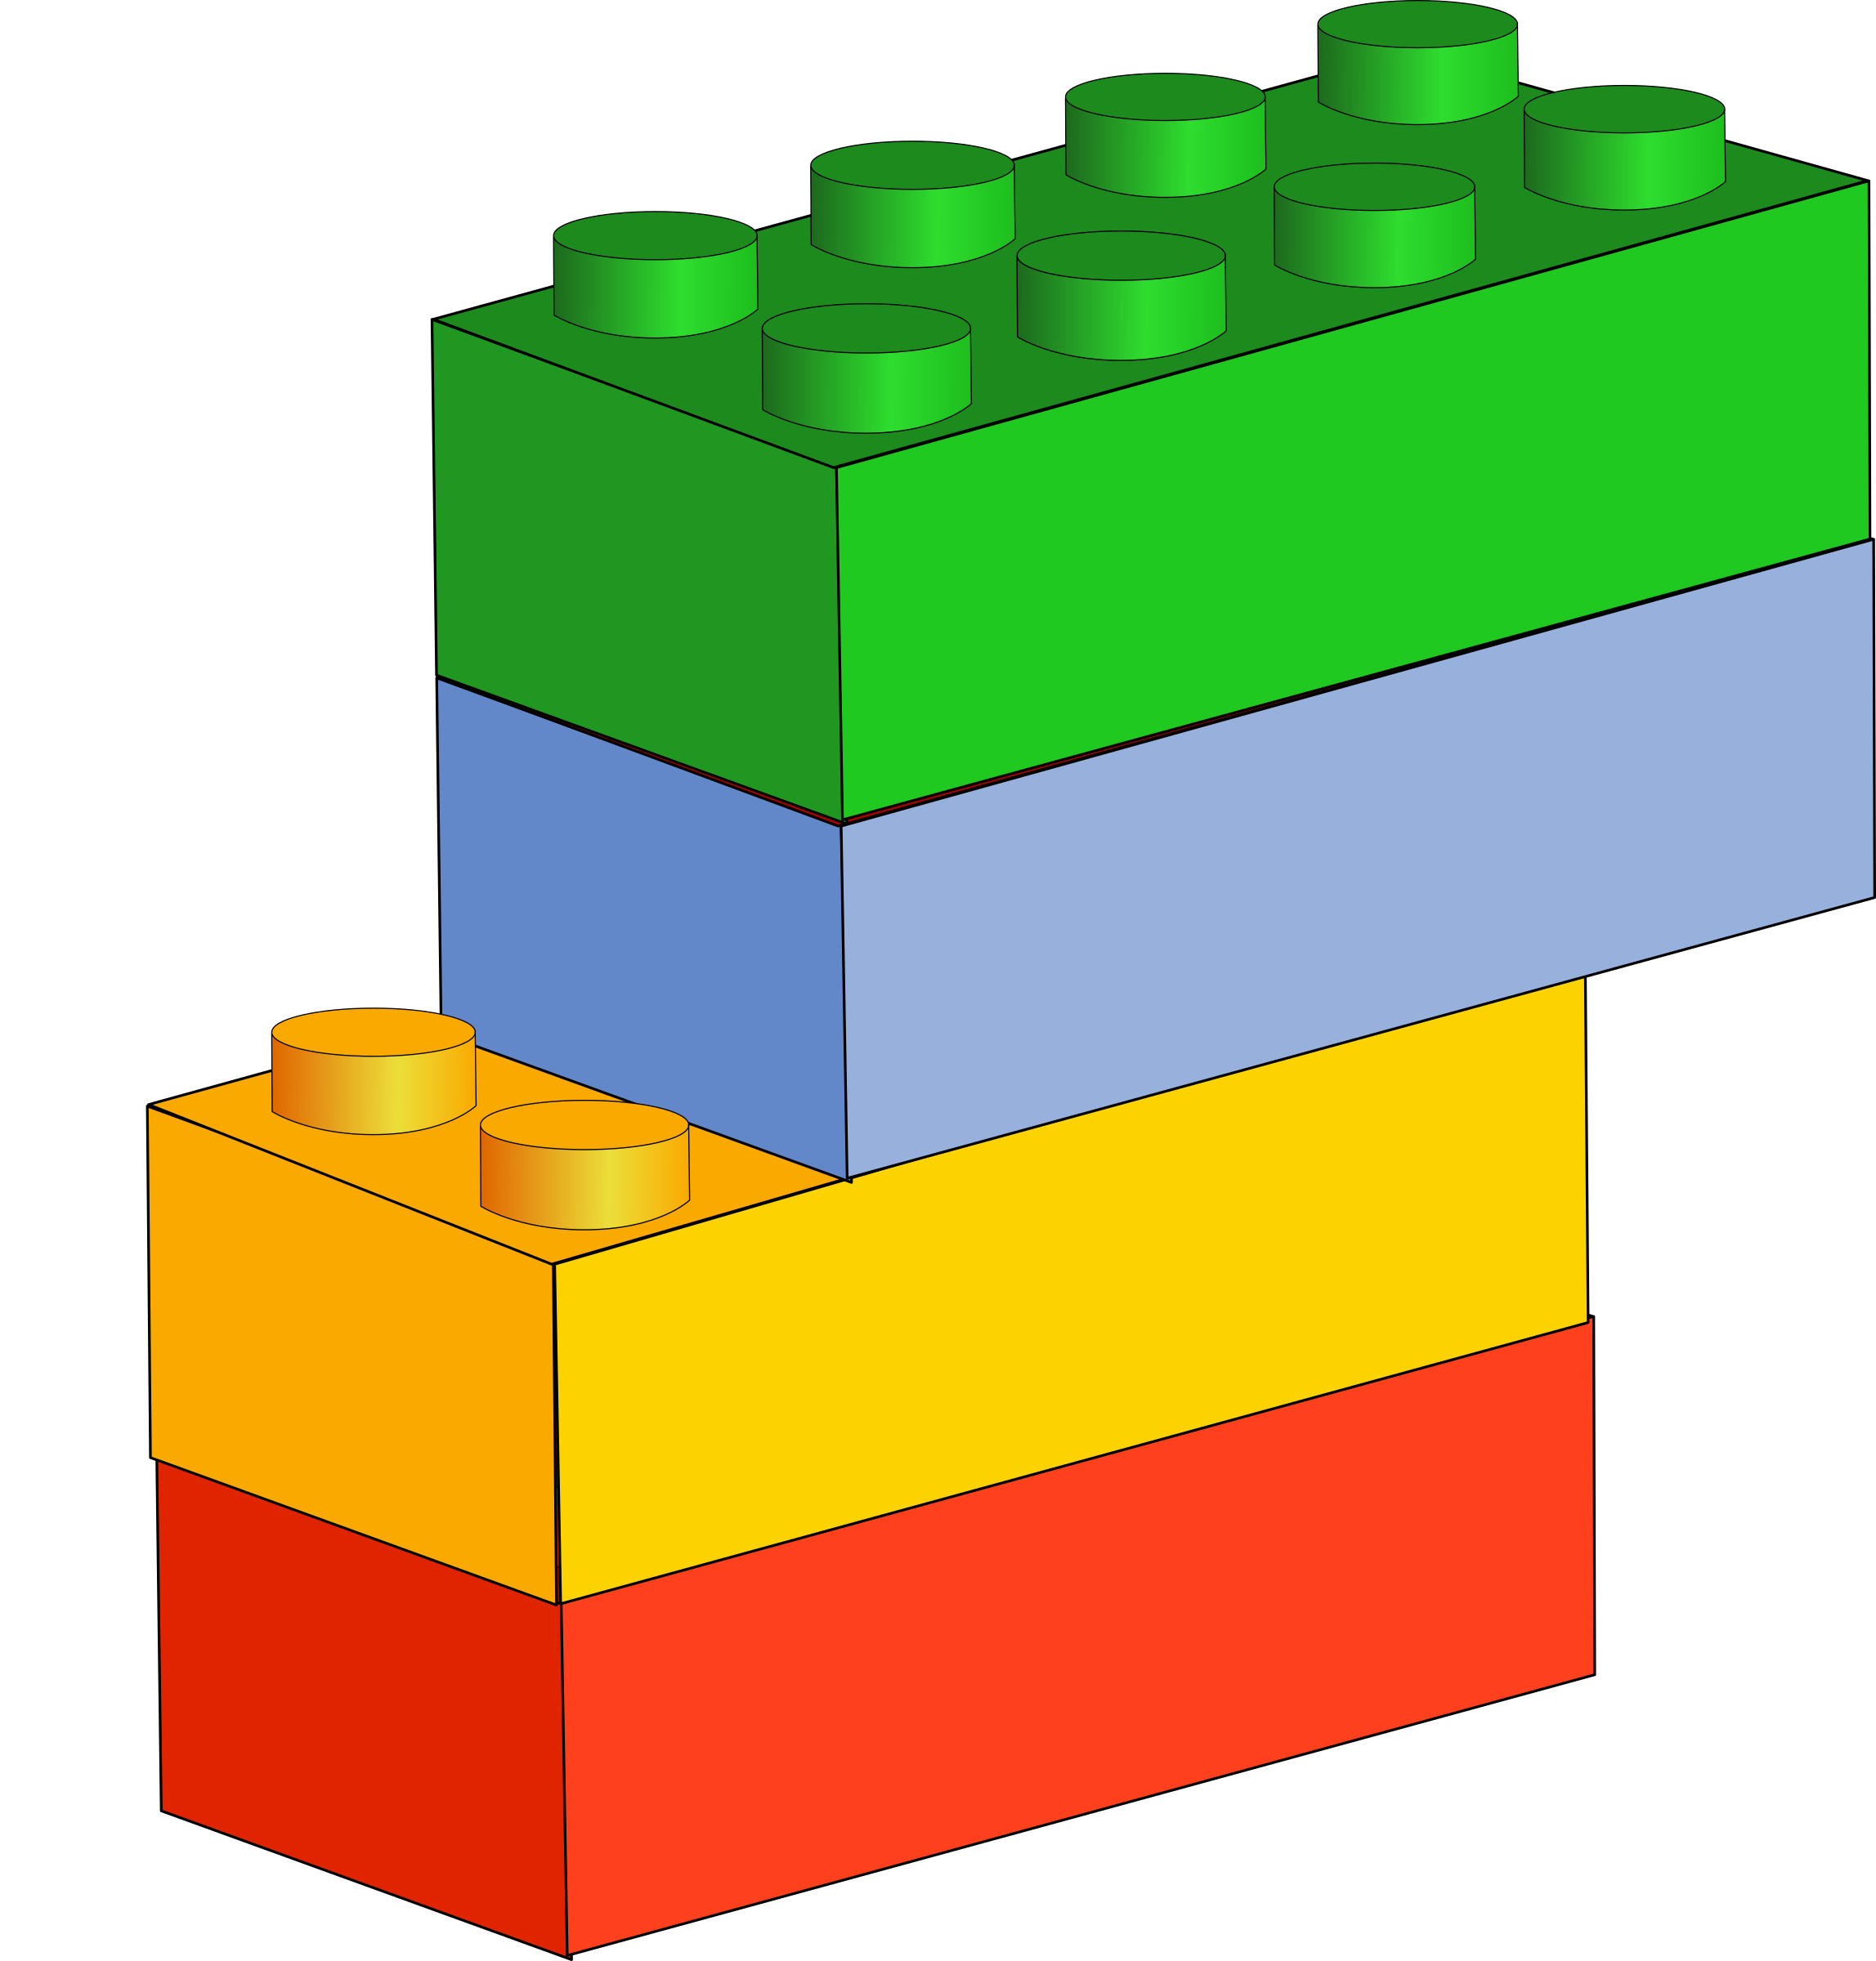

**\*Your House:** Talk about what your house looks like inside and outside. How many bedrooms does it have? Who has the biggest and who has the smallest? What makes your house a home? **Draw your house. How many windows are at the front/back? *Can you find your house on ‘Google Maps’?***

**\*Significant Places:** What do you know about where you live? **What’s the name of your village or town? What is near your house?** Use a map to find where you live**, what else is near your house?**

**\*Design a Cottage:** Compare how a cottage is different to your house. **Can you make a model of your house and a cottage?**

**Where do you live?**

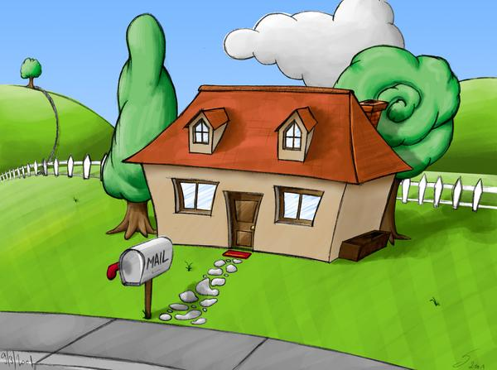

Project borrowed from Robin Hood MAT

**Maths-** Money and Time

*How many clocks to you have in your house? Are they digital or analogue? **Practise telling the time to the hour and half past the hour on them.**

*In your piggy bank (or a grown ups purse) how many coins and notes are there? **Can you sort them into groups? Can you name each of them?**

*Create a shopping list for the weekly shop. **Can you find out the least busy time to go? Can you find out how much things will cost?**

*Challenge: Have a go at the ‘Pairs of Numbers’ activity on <https://nrich.maths.org/7233>

**Writing**

*Discuss who delivers your post. How does it get to your house? **Then practise writing your address.**

*Well known addresses: **can you write a letter to someone you admire, such as the Queen, and post it?**

*Write a letter to a family member who you are unable to visit during Lockdown. **Who will you write to? What will you tell them? Will you ask them any questions?**

**\***Write out your favourite nursery rhyme or song.

**Reading**

*Listen to a story read aloud (Miss C on Tapestry on Monday, Wednesday and Friday).

*Complete a book review on one of the books you have read - **what did you like about it?**

*Draw a storyboard/ comic strip of a story. **Can you choose the main events? What would the characters say?**

**\***Use puppets or your toys to put on a show and act out a story for your family.

**Daily Expectations**

• Spend 15 minutes reading- books, comics, magazines- any reading is great!

• Spend 15 minutes doing some maths, counting backwards from 10, 20 or 100 or play on **Numbots**.

• Practise reading and writing words from the high 100 frequency word list (6 per day).

* Write each one in a sentence. Can you use more than one?

• Spend 15 minutes playing a phonics game on **Phonics Play** or **Top Marks.**

• **Year 1 –**  Spend 15 minutes on spelling shed.